**CAPSTONE TITLE: RTU: Web Based Document Management System**

**MEMBERS:**

**1. Gorobao, Carl Erwin R.**

**2. Palma, Simon Wayne**

**3. Baarde, Ian Conrad**

**4. Ison, Basteen Nicollo**

**5. Raguine, Iris Faye**

**DATA FLOW DIAGRAM**

**LOGICAL DFD**

* **Context Diagram**

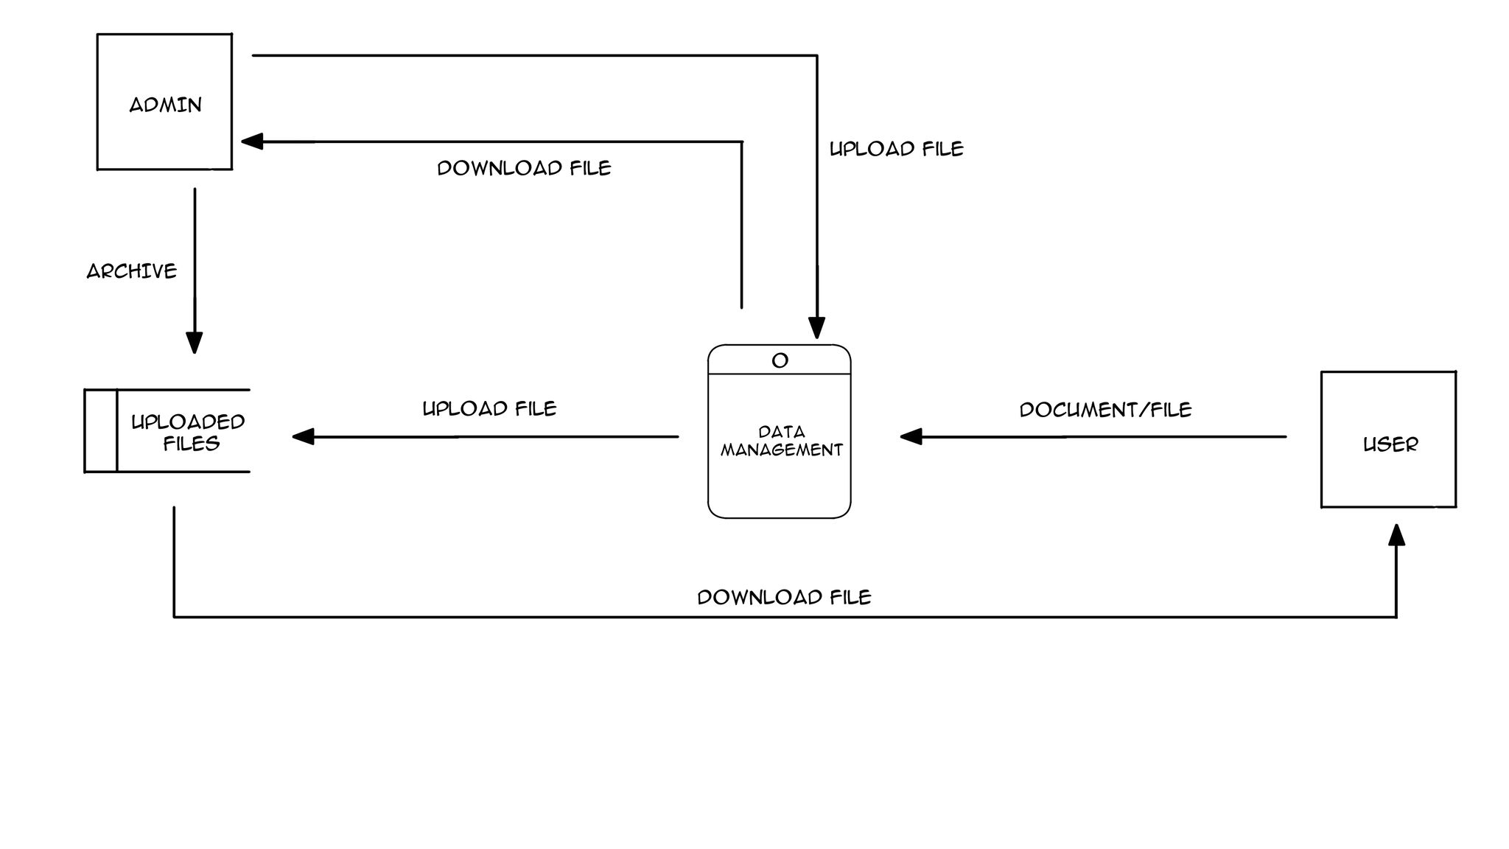

* **Diagram 0**

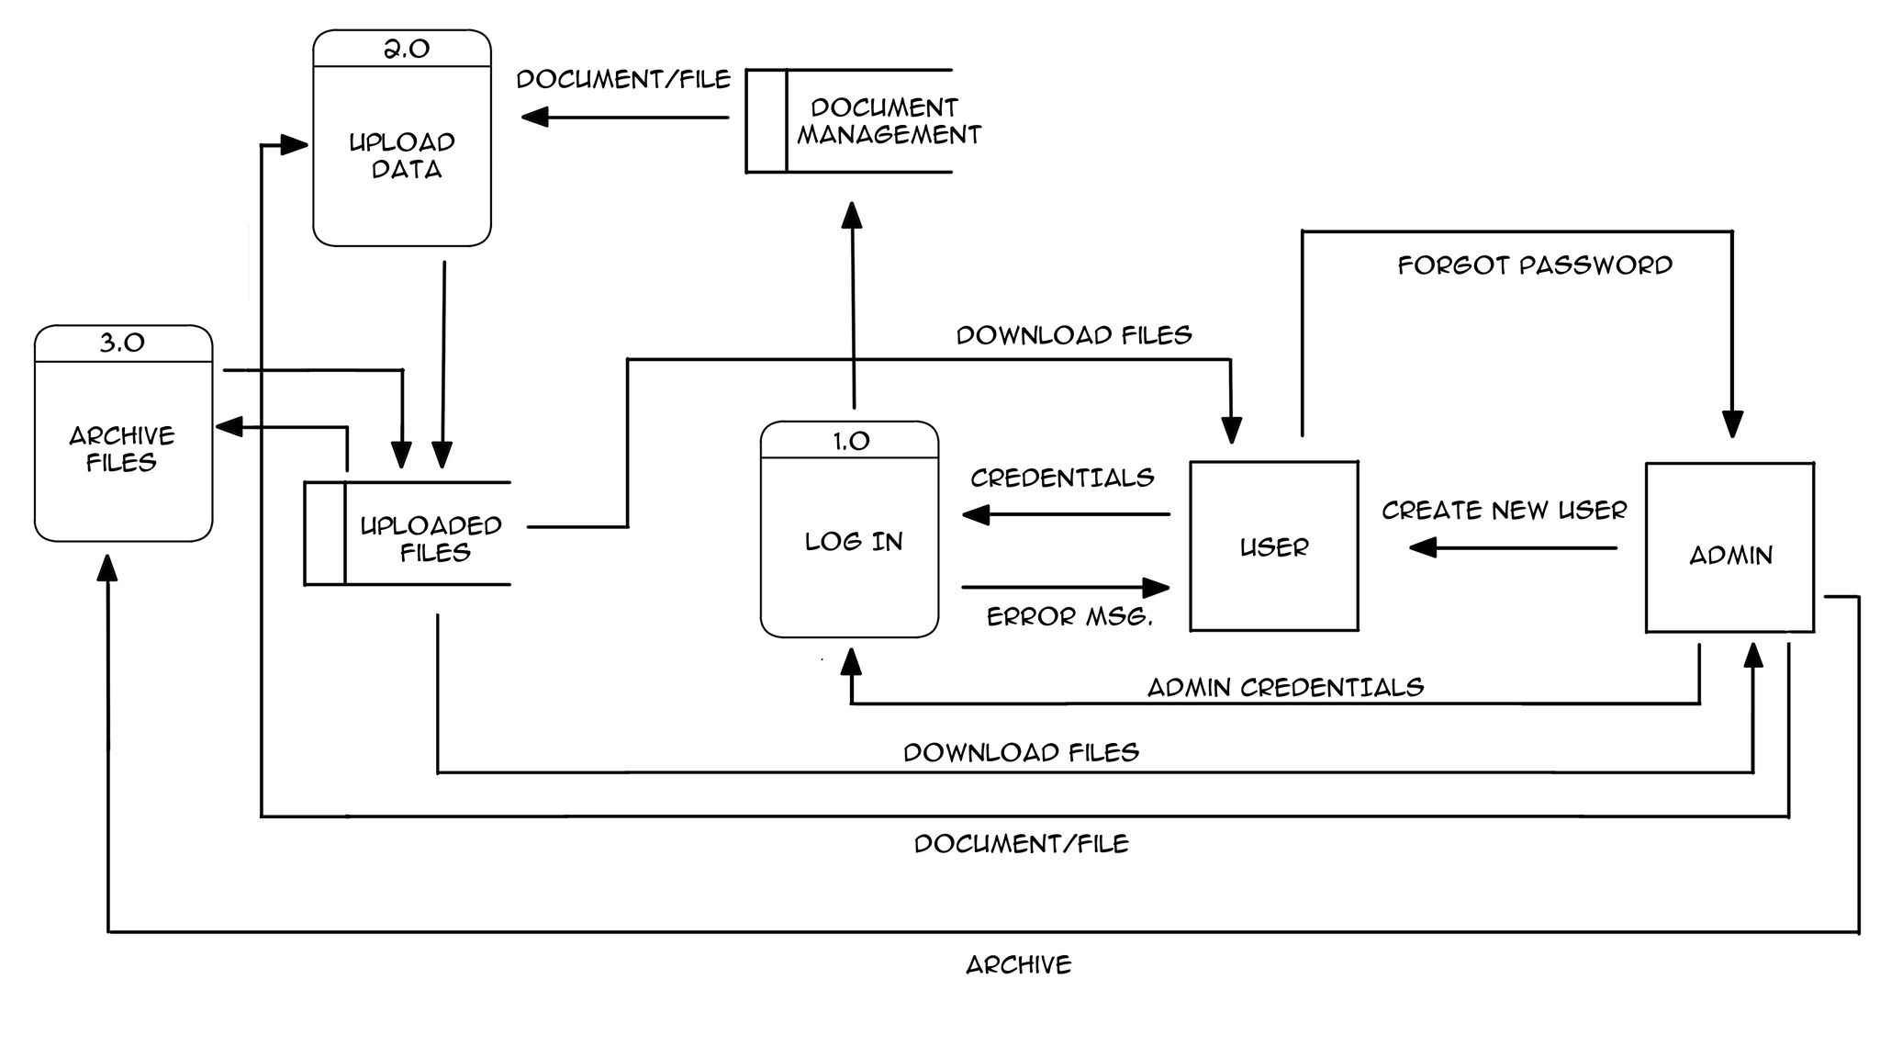

* **Child Diagram**

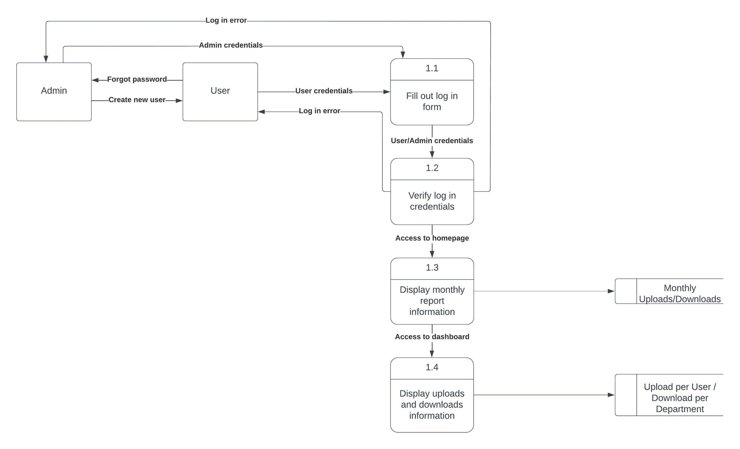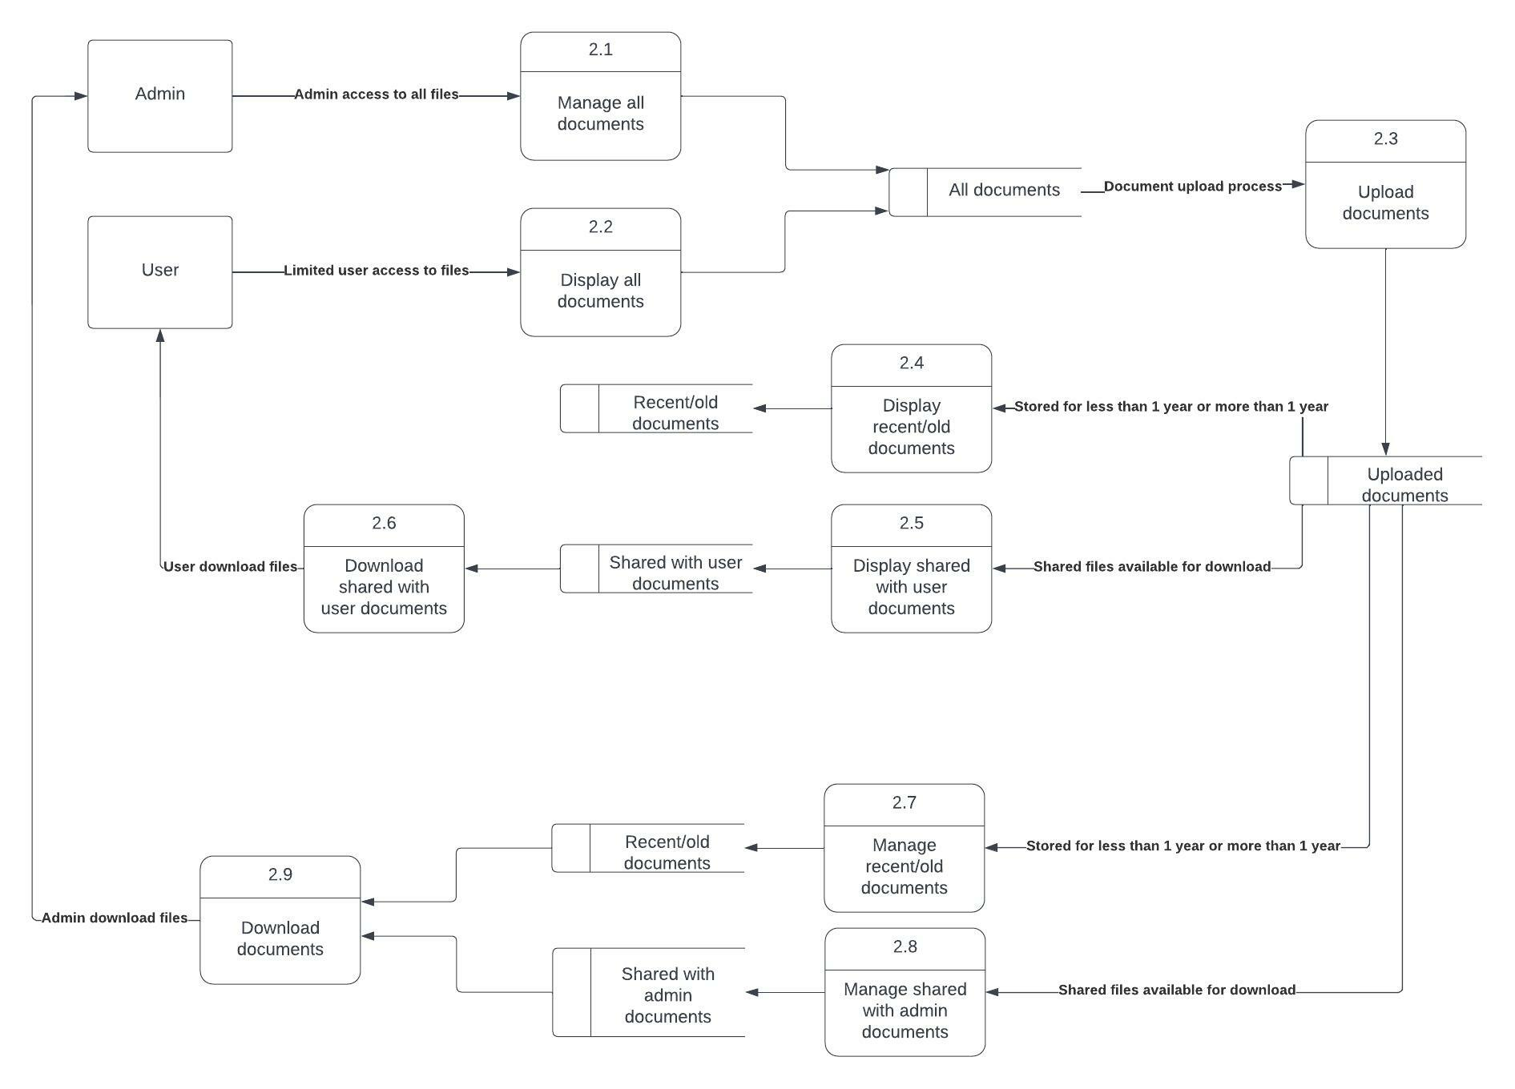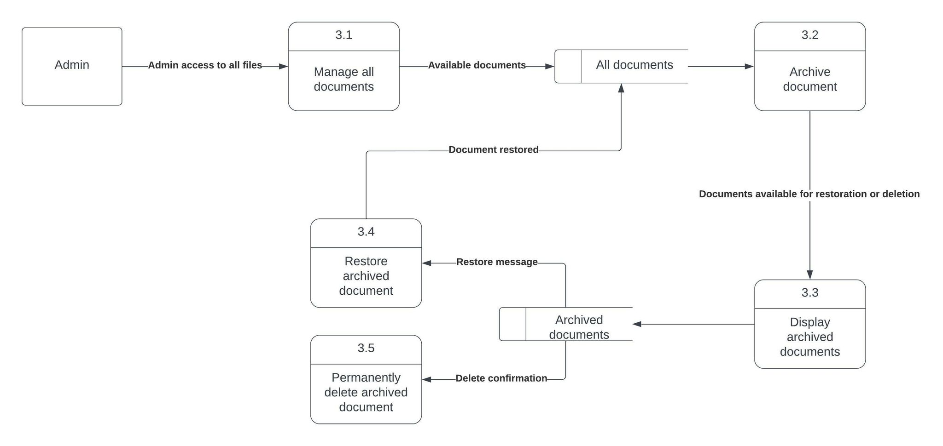

**PHYSICAL DFD**

* **Context Diagram**

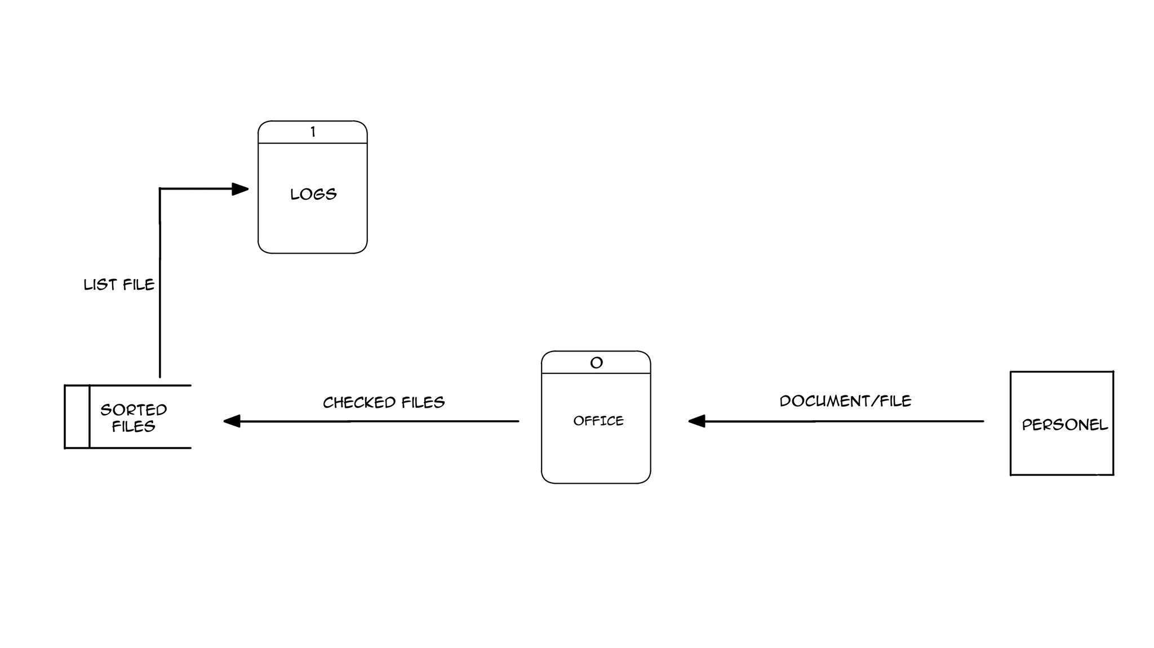

* **Diagram 0**

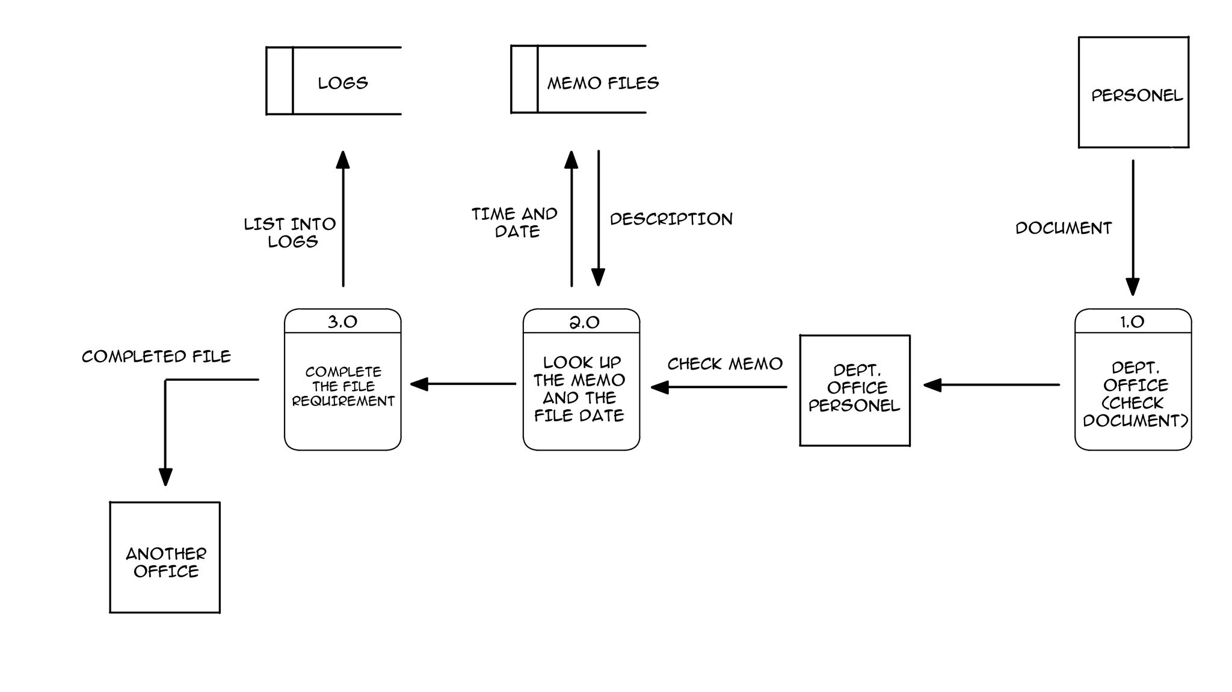

* **Child Diagram**

